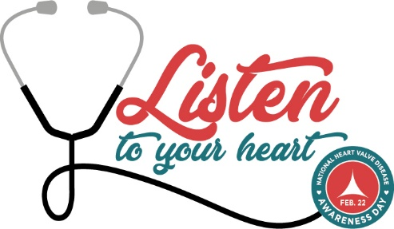

Contact Info
National Heart Valve Disease Awareness Day
Encourages People to ‘Listen to Their Heart’

Location., xxxxxx, 2018 – _____________ joins other organizations, advocates, and individuals to celebrate National Heart Valve Disease Awareness Day on February 22 to increase recognition about the risks of heart valve disease (HVD) and improve detection and access to life-saving treatment.
(Your event)

HVD consists of damage to one or more of the heart’s valves; most HVD involves a damaged valve that disrupts blood flow by not opening or closing properly. While some types are not serious, other types such as aortic stenosis can lead to major complications—including death.

At least five million Americans have heart valve disease, but public awareness about the disease is shockingly low. A survey of more than 2,000 adults found that three out of four Americans knew little to nothing about heart valve disease.

The awareness day’s theme, “Listen to Your Heart,” encourages people to know their risk factors for heart valve disease, listen to their hearts and get them checked regularly, and know where to turn if they notice symptoms.

Quote
National Heart Valve Disease Awareness Day offers a website with information about the condition at ValveDiseaseDay.org. It also includes extensive resources about HVD that can help people learn about the disease and take follow up steps.

National Heart Valve Disease Awareness Day activities will be held across the nation on February 22.
This includes a Twitter chat Q & A focused on heart valve disease at 1 p.m. EST; it can be followed using hashtag #ValveDiseaseDay. For news and updates on the day, follow the Twitter handle @ValveDiseaseDay.
More information can be found in the awareness day press kit.

###

